Apol Medrano
Heritage University 09 -18 -23
Mathematics and Computer Science Dept. Due: 09 -24 -23

C++
Homework 4
(strings, files)

1.Insert lines and find the number of words and the number of articles that are in each line and finally the total statistics.
Output: (Example) Text contains 10 words of which 4 are articles

//HW4 Q1
//Apol Medrano
#include <iostream>
#include <fstream>
#include <string>
using namespace std;
int main()
{//open the file
ifstream inStream("question1.txt");
string line;
char next;
int wordCount = 0;
int articleCount = 0;

cout << "The text:" << endl; //shows what is in file to user
inStream.get(next);
while (! inStream.eof()) //will loop until there is nothing to read in file
{
cout << next; //takes symbol from inStream displays it to screen
inStream.get(next); //grabs next character and loops
}

cout << endl;
inStream.close( ); //close it because it reached the end

inStream.open("question1.txt"); //open it again so it can start from the beginning of txt file
//start looping lines in the file
while(getline (inStream, line))
{
//loop through each character
string word = "";
for(int i=0; i<line.length(); i++)
{
char letter = line.at(i);
word += tolower(letter);//makes text lowercase to make finding articles easer
if(letter == ' ')//spaces marks the end of a work
{
wordCount++;//word count goes up if space
if (word == "the "||word == "an "|| word == "a ")
{
articleCount++;
}
word = "";
}
}
if(word.length()>0) //makes sure all words and articles are caught
{
wordCount++;
if (word == "the "||word == "an "|| word == "a ")
{
articleCount++;
}
word = "";
}
}
cout << "Text contains " << wordCount
<< " words of which " << articleCount << " are articles.\n";

inStream.close( );
return 0;
}

TEXT FILE USED IN PROGRAM:
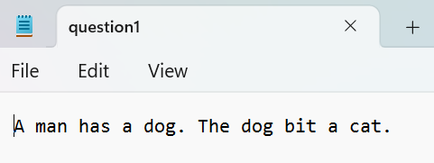
Q1 PROGRAM OUTPUT:
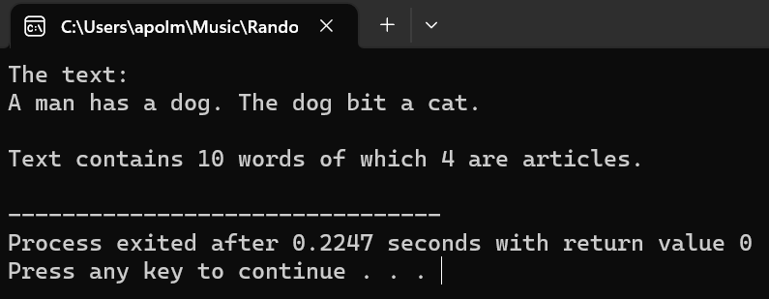

2.You have two files in1.txt and in2.txt. Prepare the processing so that from
in1.txt take all the data and put in out1.txt. The second file (in2.txt) is copied to the out2.txt.

//HW4 Q2
//Apol Medrano
#include <fstream>
#include <iostream>
#include <cstdlib>
using namespace std;
int main( )
{
int first, second, third;
ifstream inStream, inStream2;
ofstream outStream, outStream2;
char next;

inStream.open("in1.txt");
if (inStream.fail( ))//in case input file is corrupted
{ // or accidently deleted
cout << "Input file opening failed.\n";
exit(1);
}
inStream2.open("in2.txt");
if (inStream.fail( ))//in case input file is corrupted
{ // or accidently deleted
cout << "Input file opening failed.\n";
exit(1);
}

outStream.open("out1.txt");
if (outStream.fail( ))//in case output file is corrupted
{ // or accidently deleted
cout << "Output file opening failed.\n";
exit(1);
}
outStream2.open("out2.txt");
if (outStream.fail( ))//in case output file is corrupted
{ // or accidently deleted
cout << "Output file opening failed.\n";
exit(1);
}

inStream.get(next); //gets char from inStream
while (! inStream.eof()) //will loop until there is nothing to read in file
{
outStream << next; //places symbol from inStream into outstream
inStream.get(next); //grabs next character and loops
}
cout << "Copying of \"in1.txt\" to \"out1.txt\" has finished." << endl;
//will be displayed after copying (looping) is finished
inStream2.get(next);
while (! inStream2.eof()) //same process as above but with different fstreams
{
outStream2 << next;
inStream2.get(next);
}
cout << "Copying of \"in2.txt\" to \"out2.txt\" has finished." << endl;

inStream.close( );
outStream.close( );
inStream2.close( );
outStream2.close( );
return 0;
}

Q2 OUTPUT OF PROGRAM:
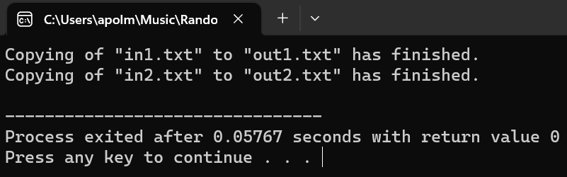
“in1.txt”:
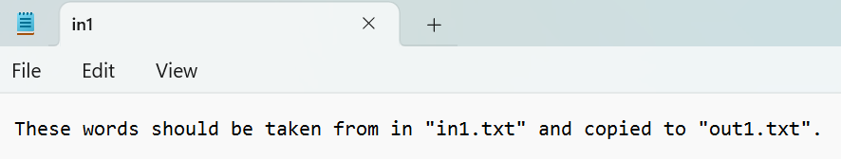

“out1.txt” (in1.txt copied into this file using the program):
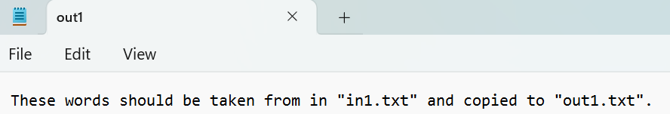

“in2.txt”:
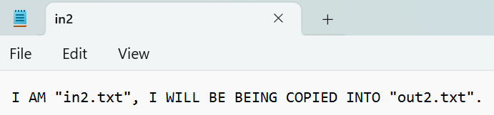

“out2.txt” (in2.txt copied into this file using the program):
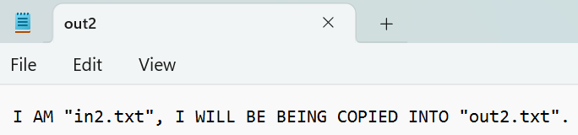

3. Prepare a game program as follows:
-randomly generate a two digit number
-the user guesses for the two numbers
-if the numbers are equal user get award $10,000
-if all the digits in the user match all the digits of the random number the award is $3,000
-if one digit in the user input matches a digit in the game number the award is:$1,000

//HW4 Q3
//Apol Medrano
#include <iostream>
#include <cstdlib>
#include <time.h>
using namespace std;
int main()
{ //generates a random number
srand(time(0));
int randomDigit1 = rand() % 10;
int randomDigit2 = rand() % 10;

cout << "Enter a 2 digit number: "; //prompts user to guess the number
int guess;
cin >> guess;
int guessDigit1 = guess/10; //finds tens digit
int guessDigit2 = guess%10; //finds ones digit
//displays random number to the user
cout << "Random number is " << randomDigit1 << randomDigit2 << endl;
//displays if their guess is a winner or not
if (randomDigit1 == guessDigit1 && randomDigit2 == guessDigit2)
{
cout << "Your guess was correct! You get $10,000!" << endl;
}
else if (randomDigit1 == guessDigit2 && randomDigit2 == guessDigit1)
{
cout << "Your guess had the same digits as the random number! You get $3,000!" << endl;
}
else if (randomDigit1 == guessDigit1 || randomDigit1 == guessDigit2 || randomDigit2 == guessDigit1 || randomDigit2 == guessDigit2)
{
cout << "One of your digits was the same as the random number! You get $1,000!" << endl;
}
else
{
cout << "You lose!" << endl;
}
return 0;
}

Q3 OUTPUT EXAMPLE 1:
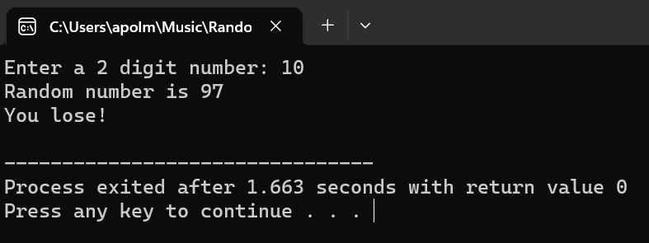
Q3 OUTPUT EXAMPLE 2:
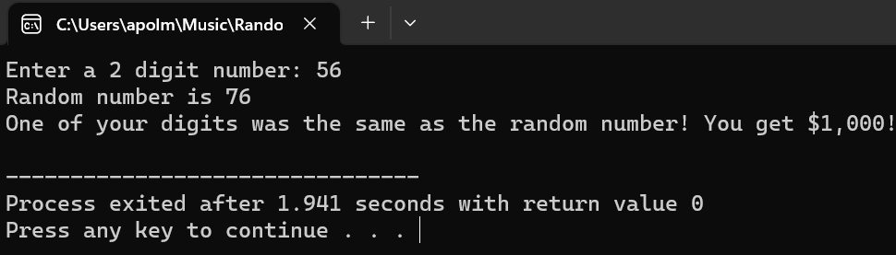

4. Compute the area of circle, square and triangle using functions overloading.

//HW4 Q4
//Apol Medrano
#include <iostream>
using namespace std;

double area (double diameter);
//calculates area of circle given the diameter
//returns the area for that circle

double area (long double sideLength);
//calculates area of square given a side length
//returns area for that given square

double area (double base, double height);
//calculates area of triangle given base and height
//returns area for that given triangle values

int main ()
{
double a, b;
long double c;
char selection;

cout << "What area would you like to calculate?" << endl
<< "A. Area of Cirlce" << endl
<< "B. Area of Square" << endl
<< "C. Area of Triangle" << endl;
cin >> selection;

switch (selection)//allows use to choose what area they would like to calculate
{//when they choose, they will prompted enter the values they know to make calculation possible
case 'A':
case 'a'://cirlce area
cout << "The diameter of the circle is: ";
cin >> a;
cout << "The area of the circle is " << area(a) << "." << endl;
break;
case 'B':
case 'b'://square area
cout << "The side length of the square is: ";
cin >> c;
cout << "The area of the square is " << area(c) << "." << endl;
break;
case 'C':
case 'c'://triangle area
cout << "The base length of the triangle is: ";
cin >> a;
cout << "The height of the triangle is: ";
cin >> b;
cout << "The area of the triangle is " << area(a,b) << "." << endl;
break;
default:
cout << "Invalid character." << endl;
}
}

double area (double diameter)
{
const double PI = 3.14159;
double radius, area;
//equation for area of circle
radius = diameter/2;
area = PI * radius * radius;
return (area);
}

double area (long double sideLength)
{
double area;
//equation for area of square
area = sideLength * sideLength;
return (area);
}

double area (double base, double height)
{
double area;
//equation for area of triangle
area = (base * height);
area /= 2;
return (area);
}

Q4 OUTPUT USING AREA OF CIRCLE:
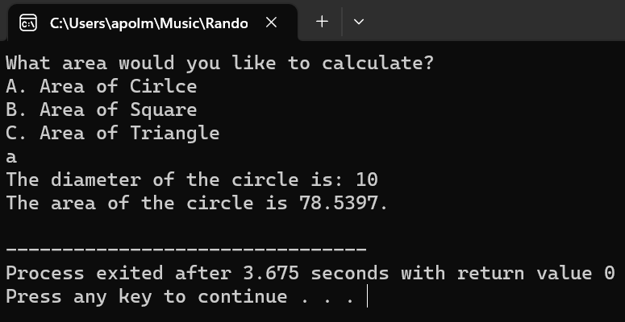

Q4 OUTPUT USING AREA OF SQUARE:
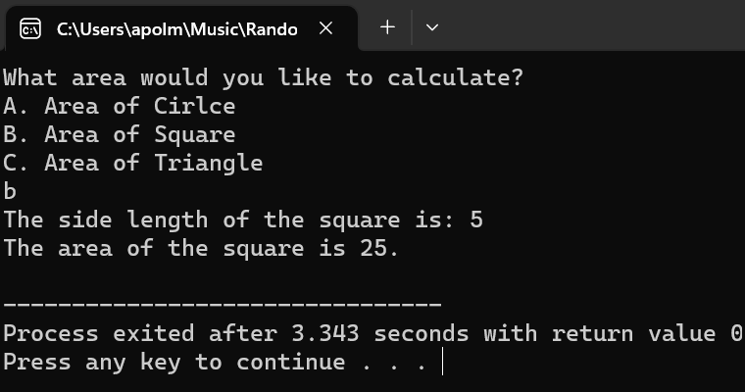
Q4 OUTPUT USING AREA OF TRIANGLE:
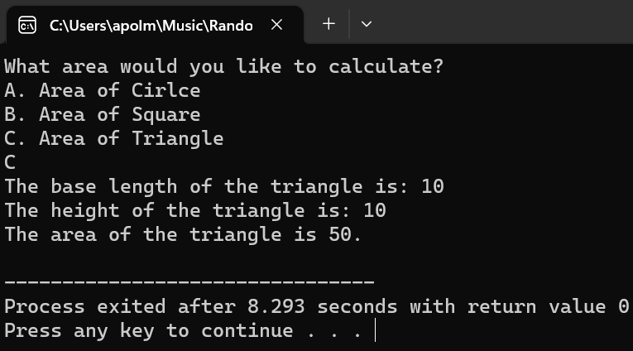

5. Please make the following steps:
- create a file with the numbers: 5,3,4.
- read the numbers, and then sort them using the swap function
- write the sorted numbers (3,4,5) in an output file

//HW4 Q5
//Apol Medrano
#include <fstream>
#include <iostream>
#include <cstdlib>
using namespace std;

void swapValues (int& firstPar, int& secondPar, int& thirdPar);
//gets numbers, and returns them swapped in a predetermined order

int main( )
{
int first, second, third;
ifstream inStream;
ofstream outStream;

inStream.open("Question_5_numbers.txt");
if (inStream.fail( ))//in case input file is corrupted
{ // or accidently deleted
cout << "Input file opening failed.\n";
exit(1);
}
outStream.open("SwappedQuestion_5_numbers.txt");
if (outStream.fail( ))//in case output file is corrupted
{ // or accidently deleted
cout << "Output file opening failed.\n";
exit(1);
}

inStream >> first >> second >> third;
swapValues(first, second, third);

outStream << first << " " << second << " " << third;
inStream.close( );
outStream.close( );
return 0;
}
void swapValues(int& firstPar, int& secondPar, int& thirdPar)
{
int temp;

temp = firstPar;
firstPar = secondPar;
secondPar = thirdPar;
thirdPar = temp;
}

Q5 PROGRAM OUTPUT:
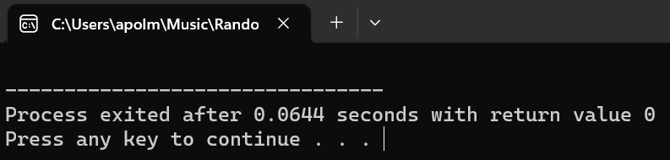

Ifstream in program (Question_5_numbers.txt)
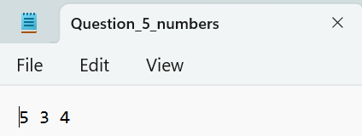

Ofstream of program (SwappedQuestion_5_numbers.txt)
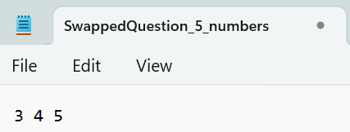

6. Create a program that read file with numbers (double) and find their average
FILE: tes.txt
DATA: 10.5 2.3 4.5 6.2 5.5 (in line breaks)

//HW4 Q6
//Apol Medrano
#include <fstream>
#include <iostream>
using namespace std;
int main( )
{
ifstream inStream("tes.txt");
double number, total = 0;
int amountOfNumbers;

//extracts numbers from file
cout << "The numbers from \"tes.txt\" are: " << endl;
while (inStream >> number)
{
cout << number << endl; //displays numbers from file to sure
total += number;
amountOfNumbers++;
}

cout << "The average of these numbers is " //displays the average of the numbers to the user
<< (total/amountOfNumbers) << endl;

inStream.close( );

return 0;
}
Q6 PROGRAM OUTPUT:
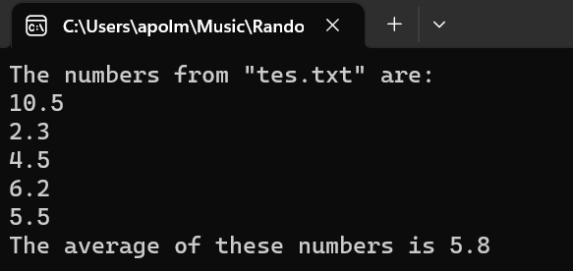
TES.TXT FILE USED IN PROGRAM:
